Financial Sector Based Analysis

Strategy Overview: We take a top-down approach in order to find securities that will generate strong returns and price appreciation. The sourcing process begins from (1) comparing industries to identify prospects, (2) comparing the top 5 firms within and (3) identifying robust financial metrics which and narrowing down into the security will generate strong returns over time. Finally, we will (4) conclude and cover strengths & limitations of our process.

**(1) Industry Overview**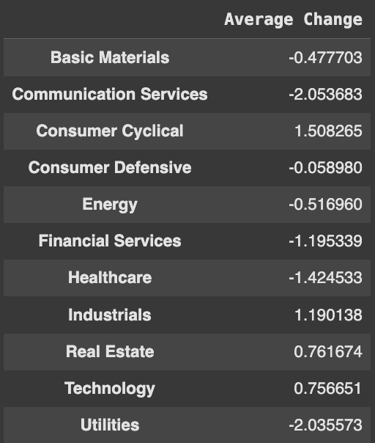

First, we utilized API Financial Modeling Prep (FMP) in order to pull the average YoY (year on year) change in sector sizes. We then aimed to identify the industries which are fastest growing, through a side by side comparison, in order to note where the highest growth prospects are. The implicit assumption made in this process is that sector growth will trickle down to firms, driving their bottom lines and driving their stock price towards their value, leading to a gain for us as investors.

**(2) Identifying Top 5 Firms**

Investing Philosophy: One belief is that the benefits of a strong industry will disproportionately trickle down into the companies which are most poised to take advantage of this growth. However, we take a different approach to investing. We look for undervalued companies, identified through a low P/E ratio, because we believe that while they may grow less than behemoths, an improvement in their earnings will lead to a more significant appreciation in valuation which will generate strong returns for us as investors.

Coding Execution:

* First, we organize the sectors in a list in descending order of YoY growth, and then assign the first value of this list to another value so that we may capture the highest growing sector and later identify the companies which operate within this.
* We achieve this through first loading the S&P500 tickers from a url, in order to aim our view at large-cap firms who we can then screen by P/E in order to find the more evidently undervalued companies.
* Next, we screen for the companies with lowest P/E in order to identify the prospective firms. The API yfinance is utilized in order to achieve this goal, and help us look at the undervalued companies out of S&P’s large basket of 500 firms.
* Now that the sourcing process has narrowed down the investment region to 5 firms, the remaining workload is to merely compare the 5 firms on various metrics in order to identify which has a stronger intrinsic valuation and is more likely to have its price converge with this valuation in the near future, as the industry it operates in continues to grow at the rate it does.

**(3) Evaluating Financial Metrics**

Investing Philosophy:

Just as different aspects of a being or entity do not speak to the whole to the same degree, we believe different financial metrics contribute differently towards an understanding of the price-value relationship of a security.

Notes on weightage:

* We believe P/E is to be the highest weight, at 0.3, because that represents the market’s perception of the value of the share in terms of the value of each $ of earnings of the company. Given our targeted securities which not only (a) leverage high growth industries but are also (b) relatively undervalued, this is logical.
* Next, EPS growth is critical to ascertain with regards to the aforementioned point (a), to gauge whether or not the firm has been able to increase its earnings and leverage the growing industry.
* Gross margin is also important to check, fundamentally, whether or not the company is even profitable after its direct costs of production. If this is not the case, then we would turn away from a potentially risky, unattractive security.
* Net Income, revenue, and price are of value but less important than the other values, and as a result we have assigned a weightage of 10% to these values.

We also understand that charts are critical to viewing trends over time, versus just on the most recent reported statements. As a result, we aim to generate visuals that allow us to engage in qualitative and quantitative analysis in order to evaluate these financial metrics and the degree to which they speak to the quality of an investment.

The key charts we aim to leverage are (i) revenue over past few years, (ii) EPS growth over past available years and (iii) stock prices over the past 20 years. Each is crucial in order to gauge the respective metric, get a sense of the security performance over time as well as the market’s view on the same.

Having established the investing philosophy for our evaluation of financial metrics, we may not proceed to the coding execution and observe how these variables were analysed in a python environment.

Coding Execution:

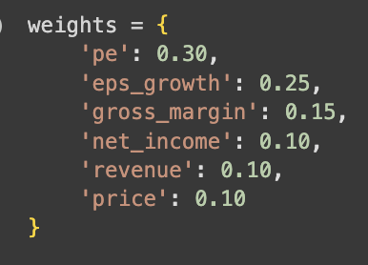

*Weightages*

As visible on the right, a dictionary of weights was constructed in order to realise the investment philosophy vision in terms of what the various weightages of financial metrics ought to be.

A dictionary was used because it allows for the iteration through in order to analyse the various metrics and streamlining the weighted average calculation which we were aiming to compute.

*Graphs*

In terms of stock price, we utilized matplotlib in order to get a picture for the past 20 years after pulling the values using yfinance. Clearly, this imagery is very useful, and to demonstrate we will run a brief qualitative analysis of the graph below.

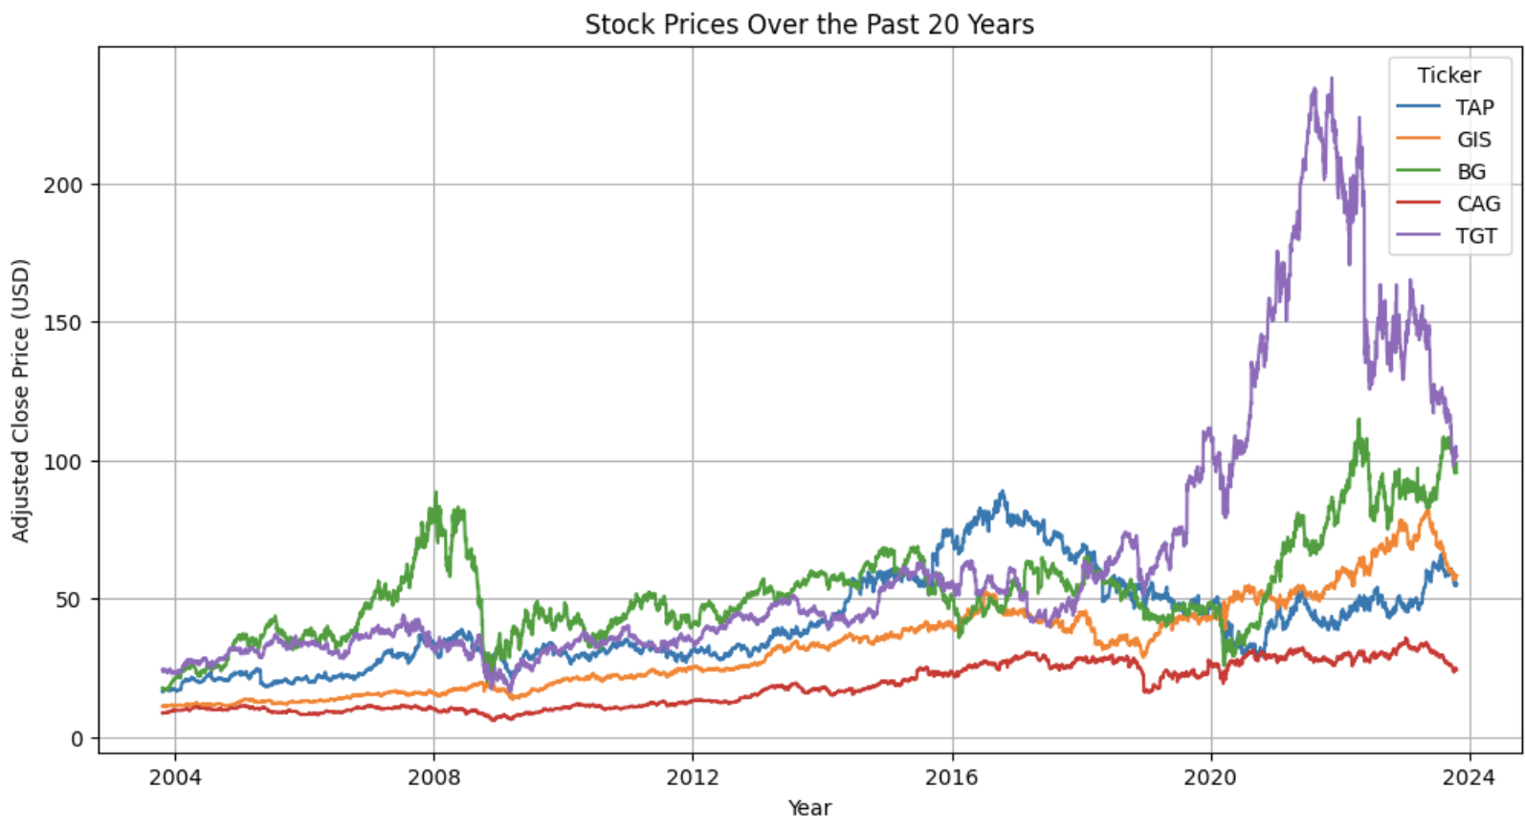

Evidently, TGT faced a high spike in ~2022 before dropping again, where CAG has the lowest stock price yet has a slow, modest growth. We may aim for a security with less volatility, then, and avoid TGT.

The below charts, which we also managed to generate, will also yield respective fruits in terms of the insights they provide. The point is that visual imagery can lead to qualitative and quantitative observations that may otherwise be hard to observe in numerical values, and ultimately we believe that generating the same would give us an edge over other investors in identifying which securities will yield the strongest returns given the sector growth.

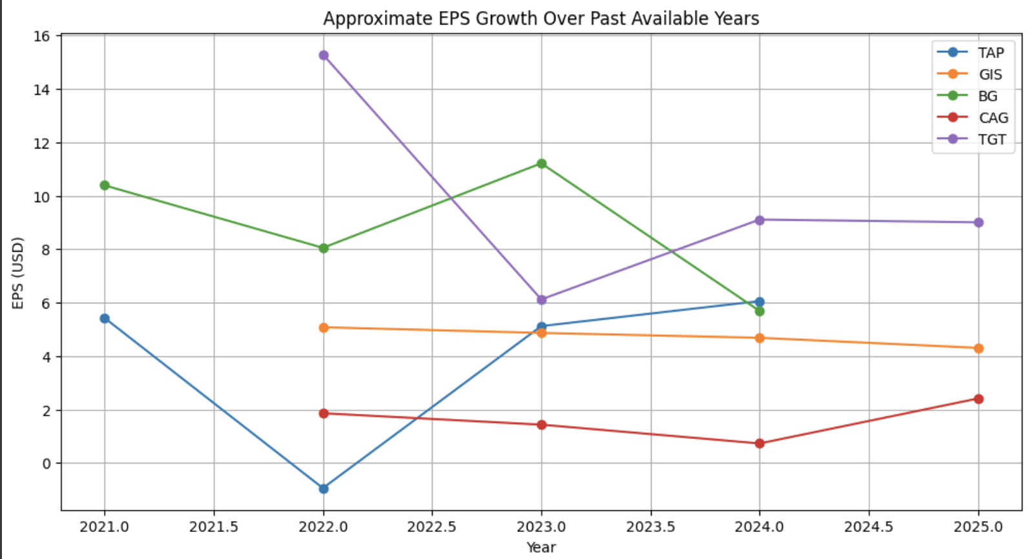

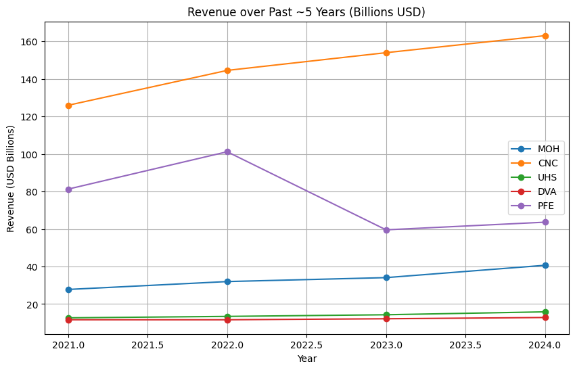

**(4) Conclusion**

*Critical Note*

Ultimately, the decision for which share is the best cannot be computerized. We provided scores using weightages, however we also gave graphs in order for the investor reading the process to have space for their own qualitative insights within the scope that is their investment decision.

*Strengths*

1. Investing is a time-bound game. One can aim to spend a lot of time sourcing the best investments and then analysing and conducting due diligence in order to determine whether it truly is the right choice of action. However, this misses one key factor which is that investing is ultimately about improving one’s purchasing power. The point is to increase one’s wealth in a way that poses a benefit to them. If it takes so long to determine an investment idea that either the idea gets realised by other market players and upside reduces as price and value converge, or the remaining time horizon left on a security is lowered, then the whole point is missed. Our methodology allows for a more efficient way for prospective investors to go about improving their purchasing power on a timely basis.
2. Coding and data continue to change. Our process is highly replicable, and changes daily based on the data of which sector is growing the fastest, which means we offer the best investments at any point in time today and can do so tomorrow as well, which means the process has a useful life beyond just the current moment in which it is executed.

*Limitations*

1. Perhaps others may have different views on the right way to come to an investment. They may fundamentally disagree with our premise of discovering the highest growing sectors, and may instead start by screening for the quality of businesses. Differences of opinion in the field of investing are inevitable, which is the reason for liquidity and mispricings in the market: at a certain share price, some people would buy and others sell, and hence trade offers are made
2. Additionally, even if an investor is to accept our premise on our view of shares in terms of targeting the highest growth industries and then going from there to discover the securities that are the highest quality and margin of safety, they may not agree with the weightages we assigned. For instance, P/E was a big factor in our decision, which is why we assigned a 30% weightage - we understand that this may not be viewed the same way across the board.
3. Data: at times, financial metrics need to be adjusted past what firms report on their financial statements. That is why utilizing yfinance may provide a bit of distortion with regards to our view on the various financial numbers for the firm, and instead opting for a recalculation and computation of certain metrics could lead to less distortion. However, we believe the impact of this aspect is minimal and would not serve as a major detriment or limitation to our investment decision.